**An Epidemic Link State Protocol**

Upon connection, nodes exchange summary vectors that list all the link state tables the nodes have received. Each table is tagged with a sequence number which permits the nodes to determine which ones are the most recent. The nodes exchange any missing updates so that they both have the same topology state. Then they recompute their routing tables and finally, messages that should be routed through the other node are forwarded.

Since we use per- contact routing, the metric for each link is temporarily set to zero to represent the fact that messages can be immediately sent to the other node. The protocol state, shown in Figure 3, is maintained individually for each connection.

To estimate the overhead of this protocol the size of each protocol message must be determined.

There are two protocol messages exchanged: summary vectors and topology updates.

**Summary vector** - one (source id, sequence number) pair for each node in the network. If we assume each value has a fixed length, the size of this message scales linearly with the size of the network.

T**opology update** - a set of (source id, sequence number, link partner id, metric) tuples for each contact. In the worst case, the complete topology must be transmitted.

In this case, the topology update has a size - the number of nodes in the network, and 􏰀 is the degree of each node.

If we assume that the average node degree is constant, this overhead also scales linearly with the size of the network.

As a somewhat realistic example, if we encode these messages as arrays and assume each value is a 32-bit integer, an 802.11 packet containing 1500 bytes of data can store an update with information about 92 links, which would be sufficient for a network with 15 nodes with an average degree of 6.

Thus, the overhead is acceptable for small networks, but may be a problem for very large networks.

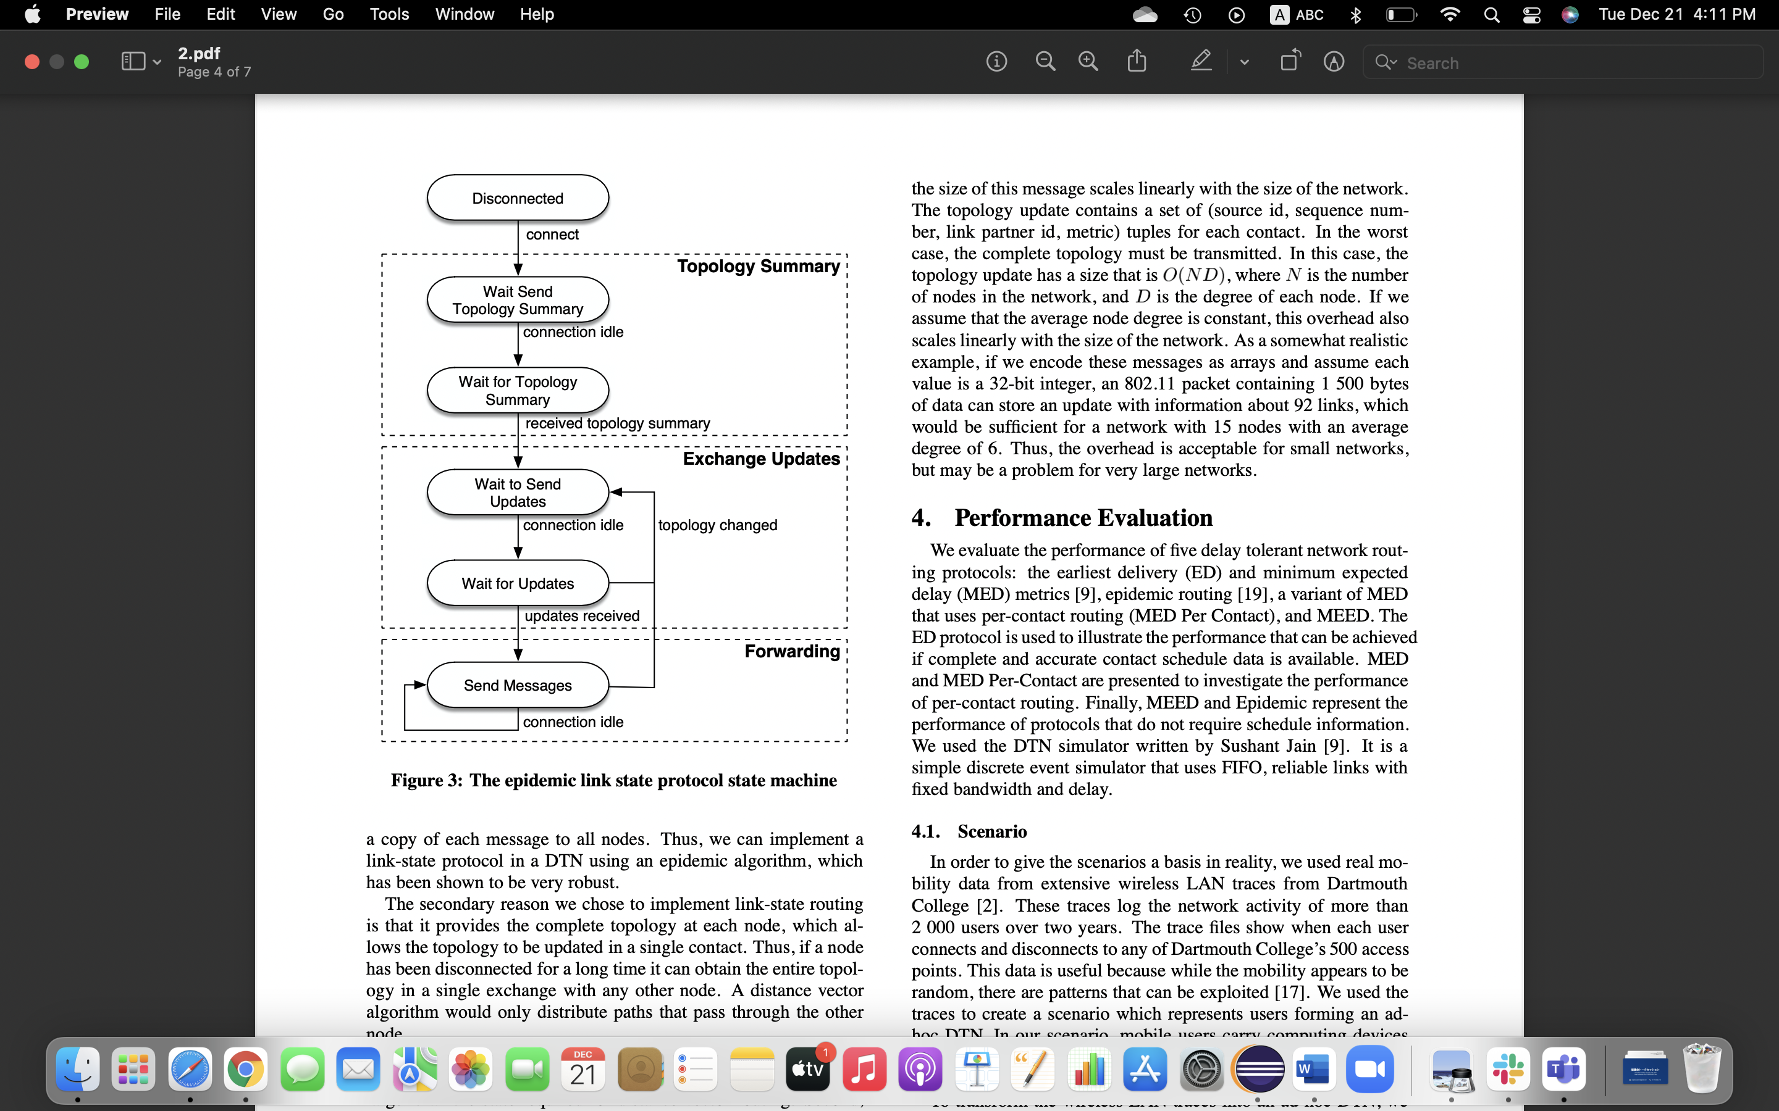

**Output for Link State protocol**

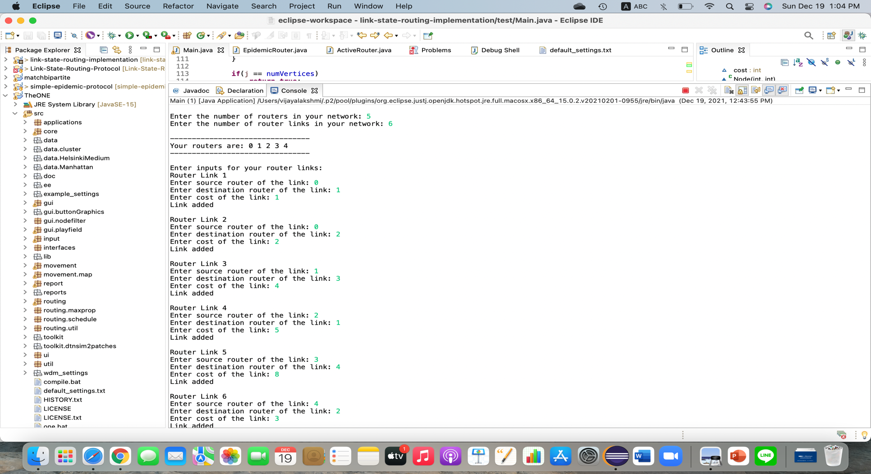

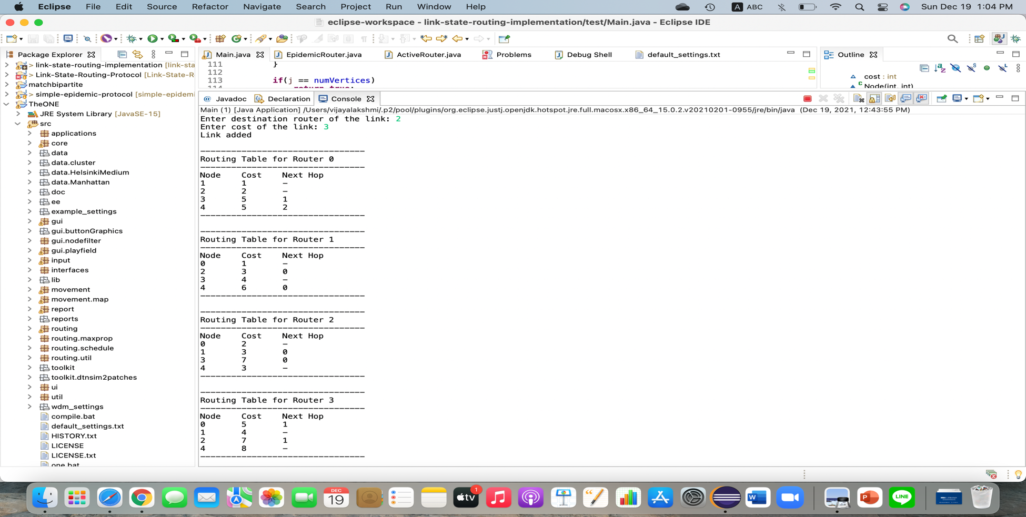

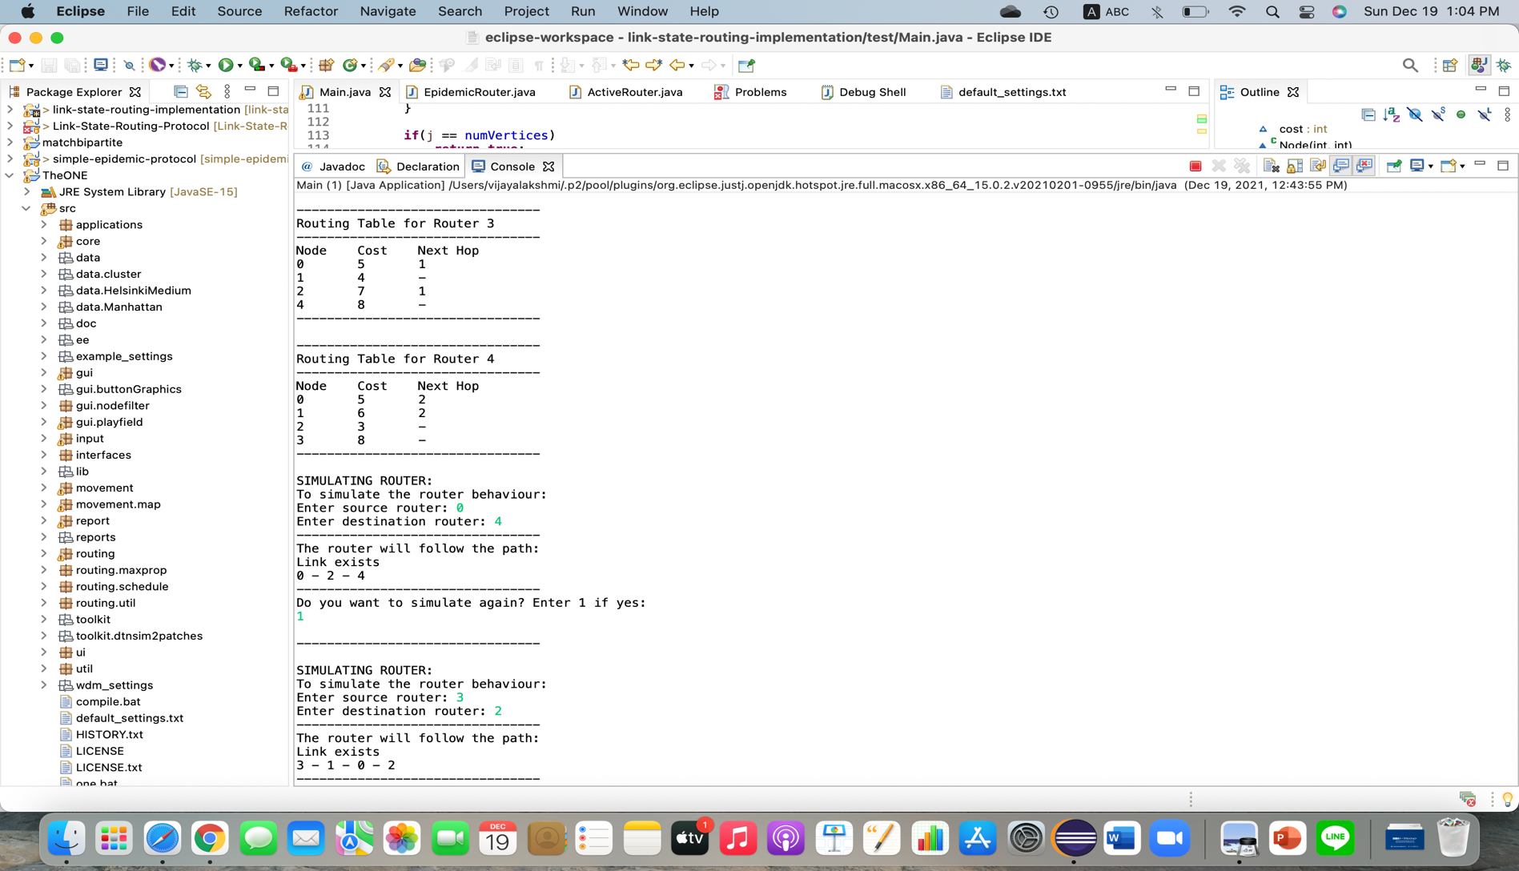

For now, I get this output for link state protocol. Furtherly, I am working on connecting the Link state protocol with Epidemic routing.

**DEFAULT SCENARIO/SETTINGS OF THE ONE SIMULATOR**

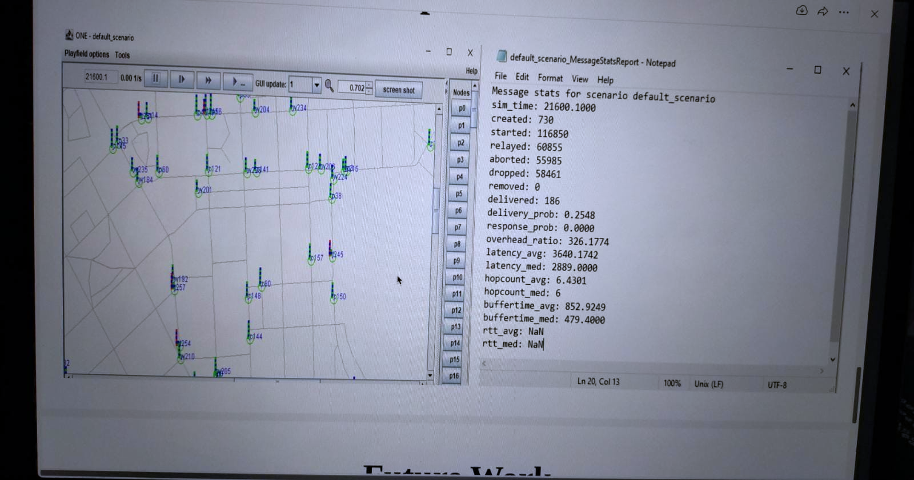

https://github.com/Viji0990/the-one/blob/master/src/routing/EpidemicRouter.java